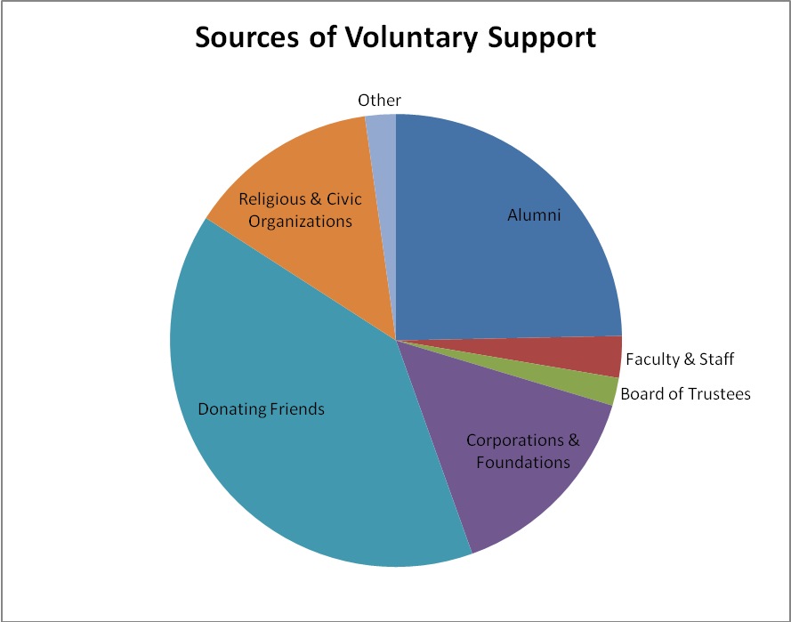

Sources of Voluntary Support
Alumni | 209,390 | 25%
Board of Trustees | 16,925 | 2%
Corporations & Foundations | 126,270 | 15%
Donating Friends | 335,868 | 40%
Faculty & Staff | 25,297 | 3%
Religious & Civic Organizations | 116,160 | 14%
Other | 18,668 | 2%

